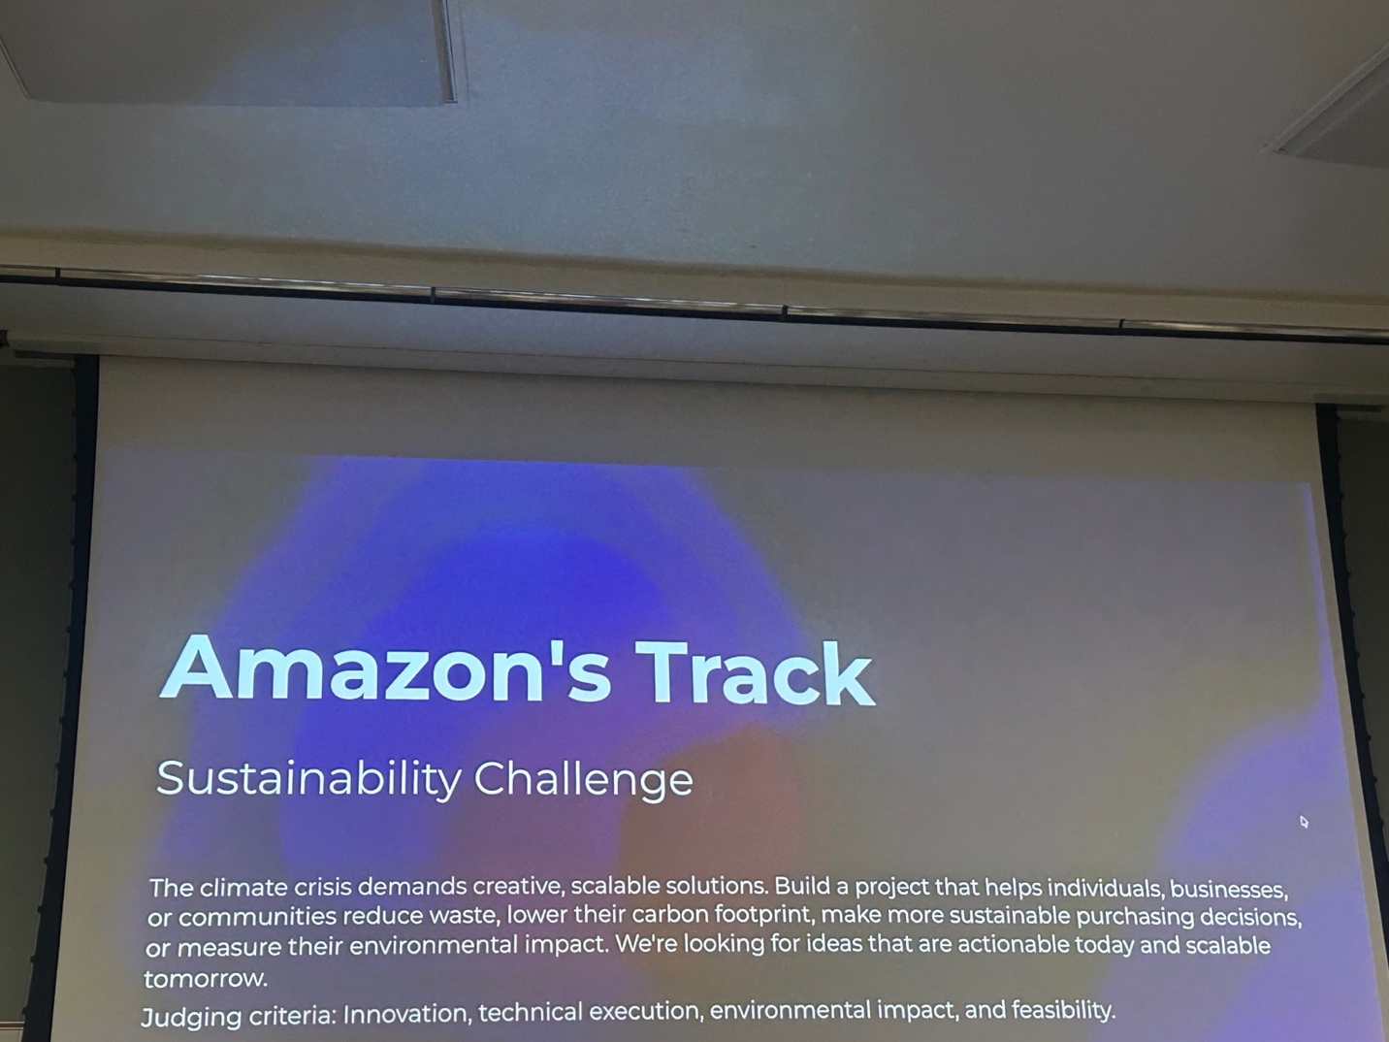
📄 Project Doc: AI-Powered Sustainable Access Economy Platform

🚨 1. Problem Statement (Aligned with Amazon Track)
The climate crisis demands scalable, real-world solutions that reduce waste and enable sustainable consumption.
However, today’s consumer ecosystem has major inefficiencies:
🛒 People frequently purchase items they rarely use
♻️ This leads to excess waste and higher carbon footprint
📦 E-commerce platforms face massive returns and inefficiencies
💤 Millions of usable products remain idle and underutilized
❌ No system exists to help users make sustainable purchasing decisions in real time
👉 The core gap:
There is no intelligent system that helps users reduce consumption while still meeting their needs efficiently

💡 2. Solution
We propose an AI-powered platform that transforms consumption behavior by enabling:
✅ Smarter decisions:
Borrow instead of buy
Choose resale over new
Avoid unnecessary consumption
✅ Key capabilities:
AI-driven recommendations
Behavioral tracking (Consumption Mirror)
Voice-based interaction
Incentivization via rewards

🔥 One-Line Solution
“An AI system that helps individuals reduce waste and carbon footprint by intelligently deciding when to borrow, buy, or avoid consumption.”

🌱 3. How It Solves Sustainability
Problem | Our Solution
Overbuying | Borrow-first recommendations
Waste generation | Resale + reuse ecosystem
Carbon footprint | CO₂ tracking + nudging
Idle products | Sharing marketplace

🧠 4. Idea Overview
We are building:
👉 Marketplace (like Amazon)
AI Decision Engine
Behavioral Intelligence System
Voice AI (ElevenLabs)

🧩 5. Key Features
🔄 1. Confidence Commerce Loop
Tracks usage after borrowing
Suggests:
Buy (if repeated usage)
Continue borrowing

🧠 2. Consumption Mirror
Tracks behavior patterns
Nudges:
“You don’t need this”
“You’ll save ₹X annually”

🎙️ 3. Voice AI Companion
Voice search
AI explains decisions
Improves accessibility

🎭 4. Sentient Listings (WOW Feature)
Items speak in first person
Generated via LLM + ElevenLabs

🌱 5. Reward System
Earn points for:
Borrowing
Choosing resale
Redeem for discounts

🔐 6. Secure AI Agents (Auth0)
Verified identities
Secure agent actions
Trust-based access

🔄 6. End-to-End Flow
User searches (text/voice)
AI evaluates:
Availability
User behavior
Sustainability impact
System shows:
Borrow
Resale
Buy
AI explains via voice
Item speaks (sentient listing)
User takes action
System:
Tracks behavior
Updates profile
Rewards user

🤖 7. Agentic AI (Minimal & Strong)
1. Decision Agent
Decides:
Borrow / Buy / Avoid
2. Lifecycle Agent
Tracks long-term behavior
Triggers:
Buy suggestions
Nudges
Rewards

🧩 8. System Architecture (AWS)
Next.js Frontend
↓
API Gateway
↓
AWS Lambda
↓
Core Services:
- Decision Engine
- Consumption Engine
- Reward Engine
- Voice Service
↓
DynamoDB (data)
S3 (assets)
↓
External APIs:
- LLM (Bedrock/OpenAI)
- ElevenLabs
- Auth0

☁️ 9. Tech Stack
Frontend
Next.js
Tailwind CSS
Backend (AWS)
AWS Lambda
API Gateway
AWS CDK (TypeScript)
Database
DynamoDB
S3
Auth
Auth0
AI
AWS Bedrock / OpenAI
Rule-based + LLM
Voice
ElevenLabs

🧬 10. Data Model
Users:
user_id
trust_score
reward_points
Items:
category
condition
pricing
location
Transactions:
borrow / buy
duration
Events:
search
view
borrow
buy
Consumption Profile:
usage patterns
repeat behavior

📊 11. Data Strategy
Synthetic Data (Hackathon)
50–100 users
200+ items
500+ transactions
Patterns:
Repeat borrow → suggest buy
Low usage → suggest borrow

⚙️ 12. Deployment (AWS CDK)
cdk bootstrap
cdk deploy
Infra includes:
API Gateway
Lambda
DynamoDB
S3

🎬 13. Demo Flow
Voice search
AI recommendation
Item speaks
User borrows
Show:
CO₂ saved
Reward points
Later:
Buy suggestion triggered

💰 14. Business Value (Amazon Alignment)
New revenue streams:
Rentals
Resale
Reduced returns
Better customer trust
Increased retention

🏆 15. Final Pitch Line
“We are building a scalable AI-powered system that reduces waste and carbon footprint by transforming how people consume—shifting from ownership to intelligent access.”

